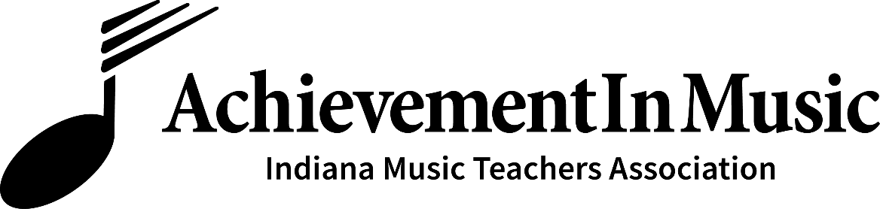

Dear Students and Parents:

Thank you for your interest in the AIM (Achievement in Music) Festival to be held at the Bethel University Everest-Rohrer Building on the lower level on Saturday, November 13, 2021. AIM is a fun, non-competitive event sponsored by the South Bend Area Music Teachers Association.

The AIM Festival provides well-rounded musical goals for each year's study, as well as an assessment of the student's performance skills and musical understanding. Evaluation will take place in the following areas: performance (two contrasting selections, one of which is memorized), keyboard skills, sight-reading, aural skills, and written theory. Each participating student will receive a certificate, medal, and evaluation form, which will be distributed by their teacher at a lesson or recital following the AIM Festival.

Please confirm your desire to participate in this year's AIM Festival by completing the form below and submitting the entry fee of $20 per student,
payable to me, your teacher, by __________________, 2021.

I look forward to helping you prepare for this exciting event.
Sincerely,

_____________________________________________

----------------------------------------------Detach here---------------------------------------------

Yes! ____________________________________________________
will participate in the AIM Festival at BETHEL COLLEGE on Saturday, November 13, 2021.
My entry fee of $20 per student is enclosed.

Parent _________________________________ Phone _________________________

e-mail___________________________________________________

